**CLOUD** **COMPUTING**

**ASSIGNMENT** – **2**

Name : Sanmat Sanjayakumar Payagoudar

SRN : PES1UG20CS385

Section : G

**TASK – 1 :**

1. Screenshot of the running Docker Container after installing Jenkins

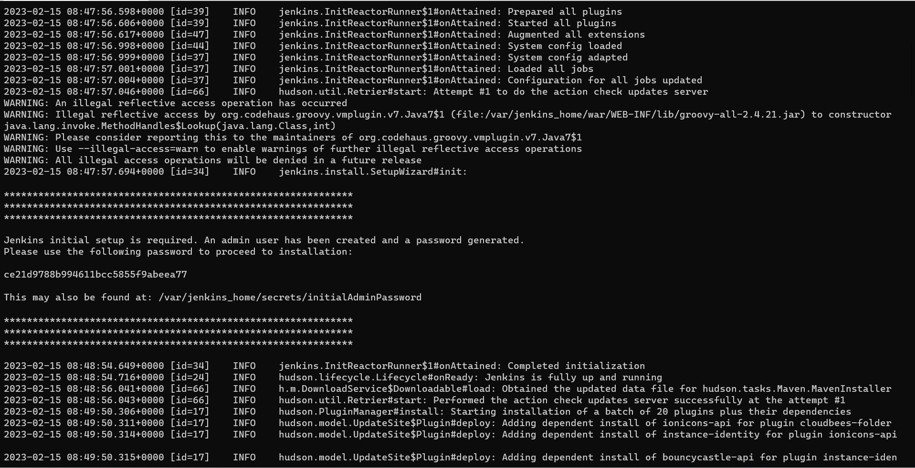

**TASK – 2 :**

1. Picture showing the console output after the build is successful

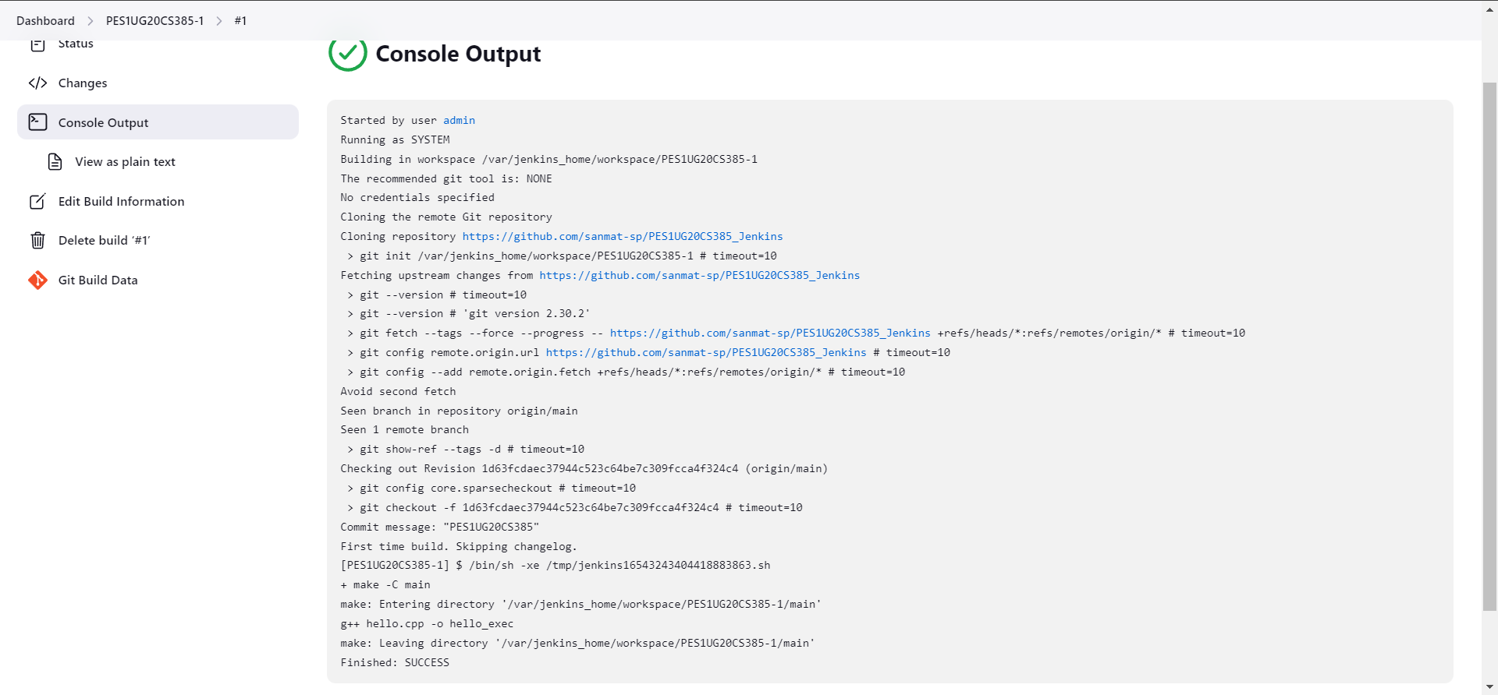

1. Picture showing the Stable state of the task in Build History of Jenkins

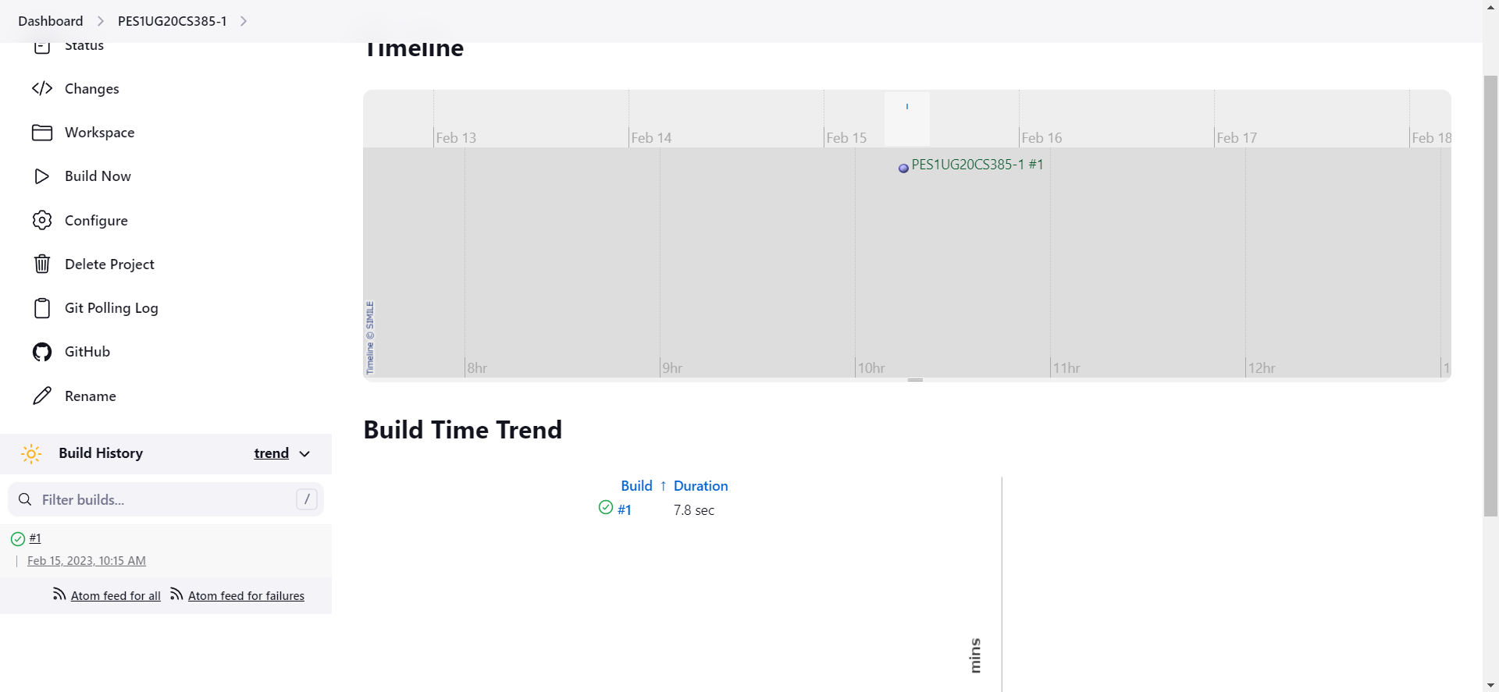

**TASK – 3 :**

1. Console output of second job

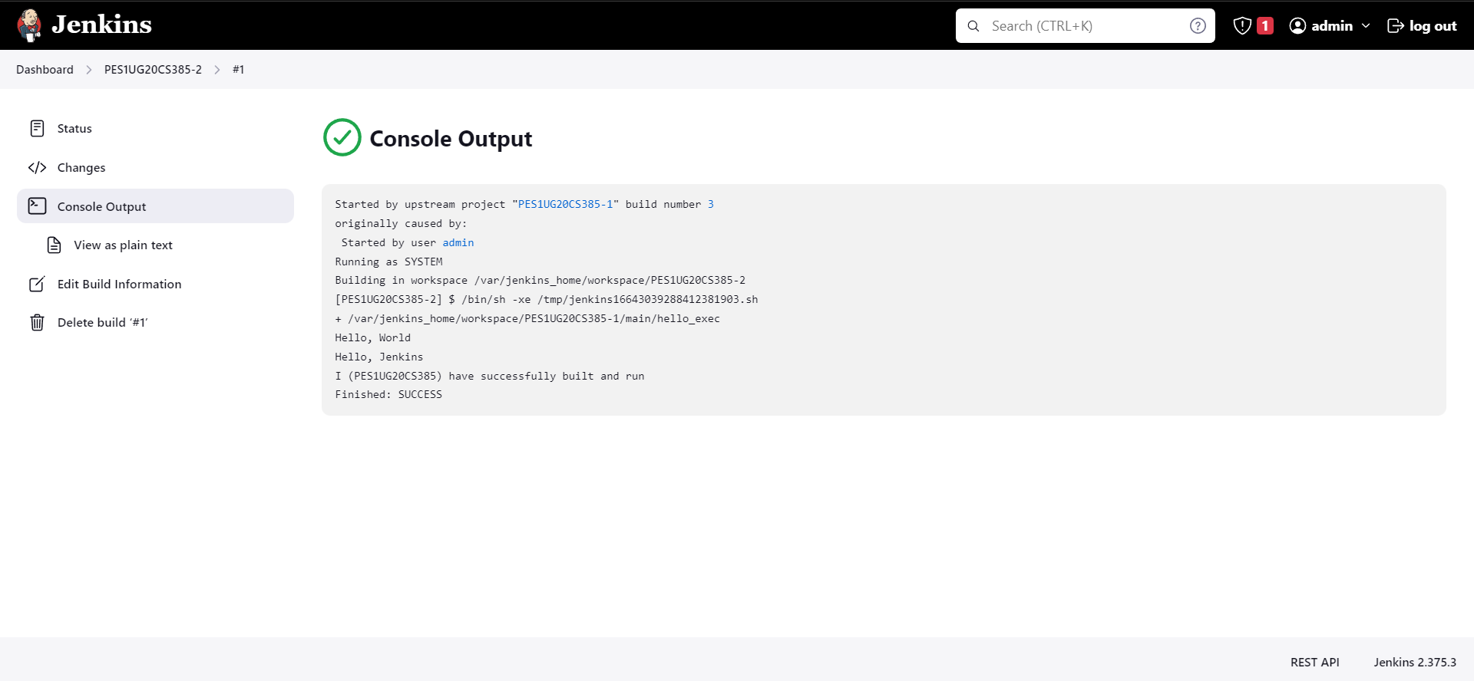

1. Status page of first job

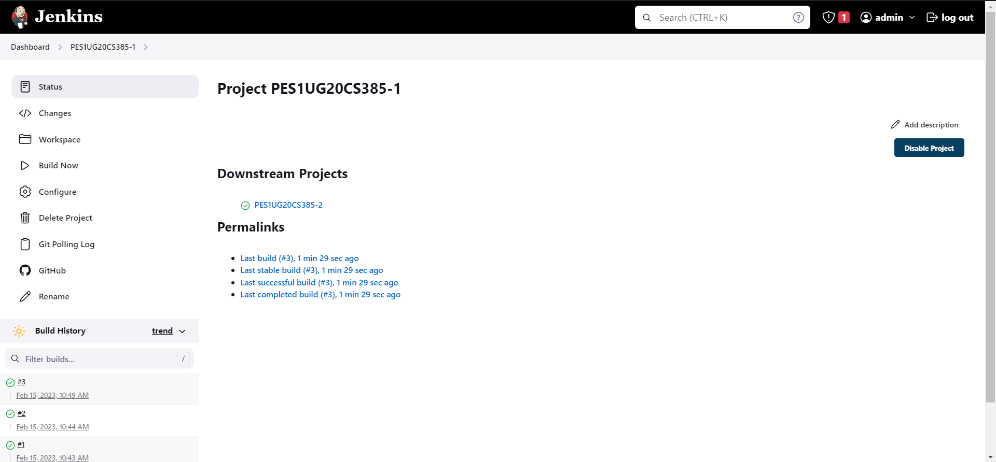

1. Build History of Jenkins

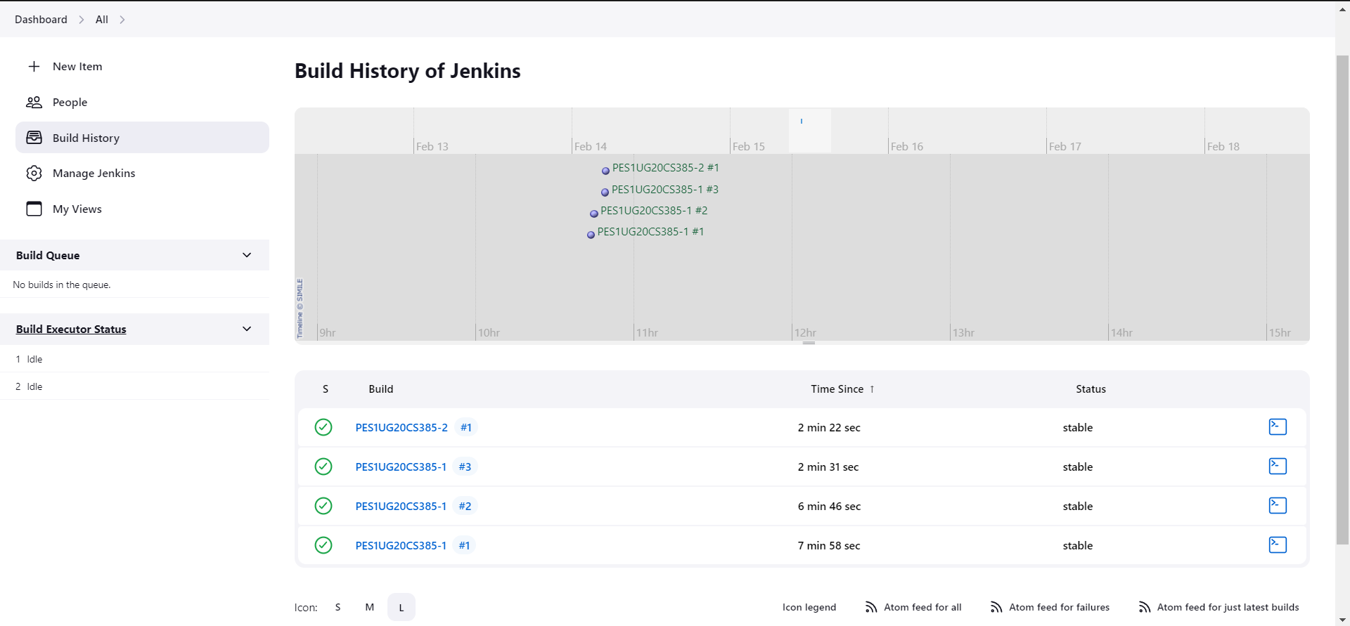

1. Jenkins Dashboard

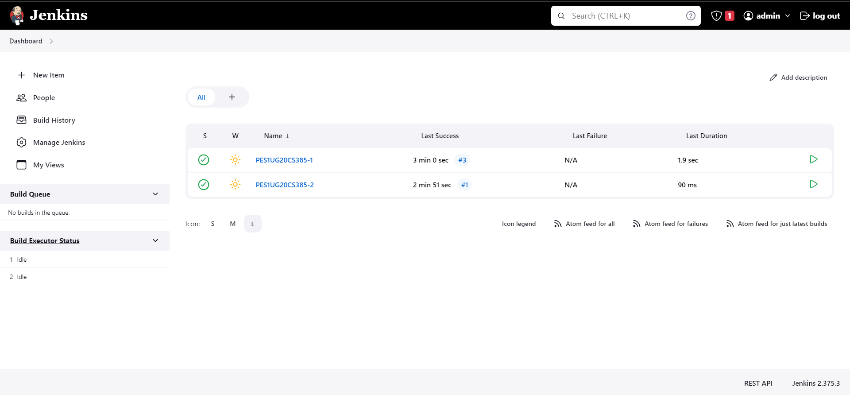

**TASK – 4 :**

1. Webhook added to your GitHub repository

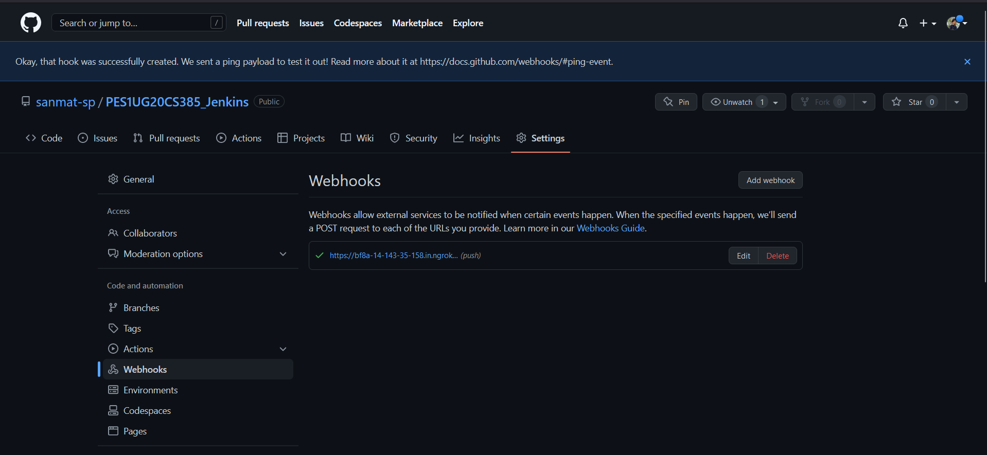

1. Console Output of second job displaying the change made in hello.cpp file

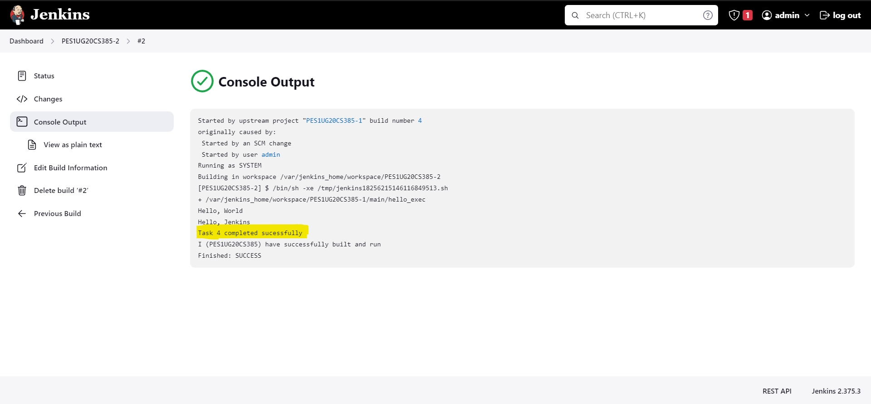

**TASK – 5 :**

1. Code written to create basic pipeline using GitHub repository

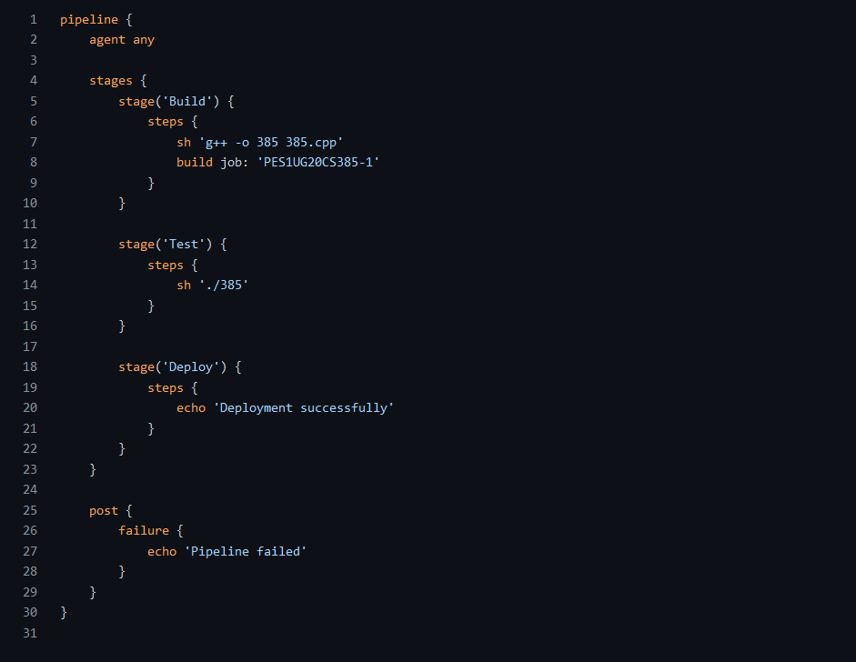

1. Output of working created pipeline, the screenshot should include

* Stage view / Execution status of pipeline with all stages succeeded

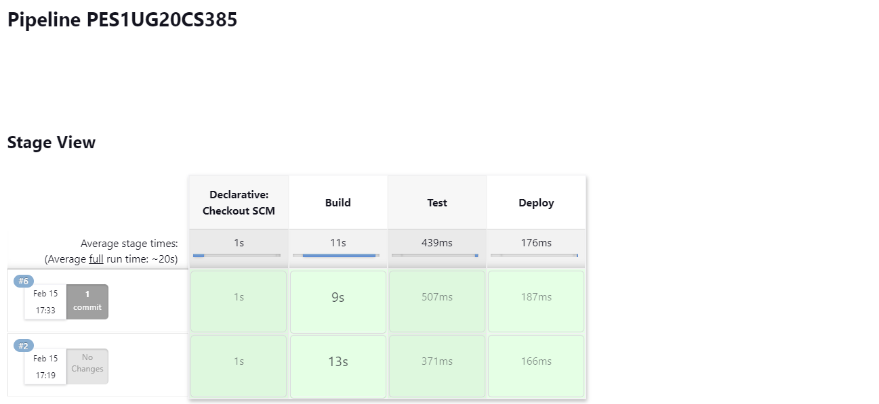

* Verify Declarative: Post Actions stage succeed for handling failures

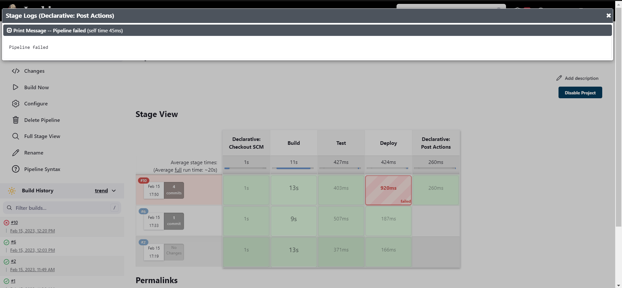

1. Console Output of the Pipeline (Successful Pipeline)

* Build and Test stage

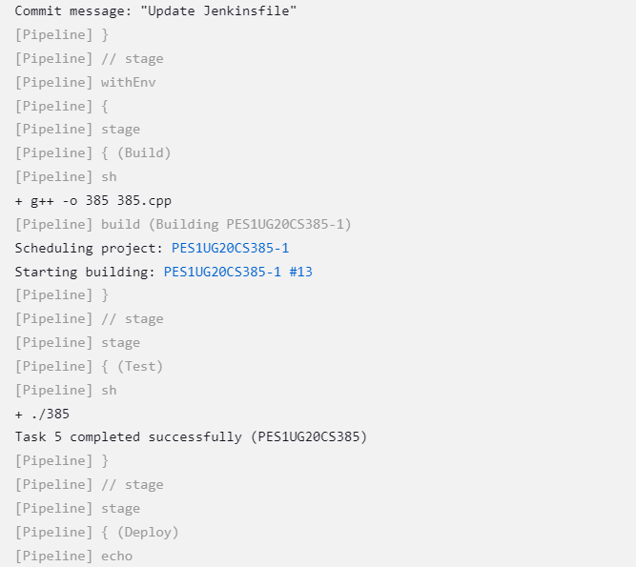

* Deployment and Success

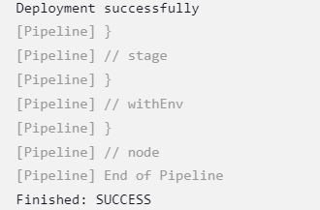

1. Link to the created GitHub repository

<https://github.com/sanmat-sp/PES1UG20CS385_Jenkins>